SilverDoor expands into the Middle Eastern market


Released on: May 1, 2009, 5:08 am
Author: SilverDoor
Industry: Real Estate
SilverDoor has increased its Middle Eastern portfolio to cover Bahrain, Qatar and the UAE following unprecedented growth.
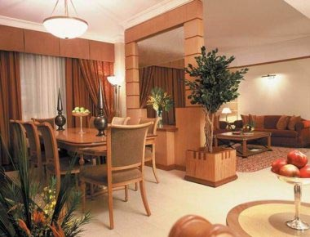
SilverDoor now represents almost twenty properties in the Middle East and is continuing to grow its Middle Eastern collection by adding new properties weekly. Doha, Bahrain and Dubai are currently represented with Dubai having over ten properties covering different locations within the City. SilverDoor has also added some new serviced apartments in Abu Dhabi.
"Dubai now has so much to offer that we have had to concentrate on developing this market and have recently sent someone out to the Middle East to source property for us. Dubai serviced apartments is a huge market for us." Marcus Angell, Founder of SilverDoor and Managing Director said. "Abu Dhabi is also a very popular destination for us due to this being the seat of the federal government and the country's capital and also being the home of some of the world's biggest oil producing companies. We get inundated with enquiries on these areas. Everyone appears to want a serviced apartment in Abu Dhabi at the moment."
Media City Apartments located in the Media City of Dubai is SilverDoor's newest addition. Overlooking the renowned Palm Island, these new apartments are available in a range of sizes and layouts including duplex apartments and a range of one, two and three bedroom apartments. The epitome of luxury, the ground floor apartments offer a private plunge pool whilst the apartment block has an on site fitness room as well as 24 hour concierge and 24 hour room service. SilverDoor also offers apartments overlooking Dubai Creek as well as serviced apartments within Dubai Marina. The Green Community Apartments located in Green Community Village close to Jebel Ali, offers clients the chance to be surrounded by sixty seven hectares of landscaped parkland and to escape from the hustle and bustle of Dubai.
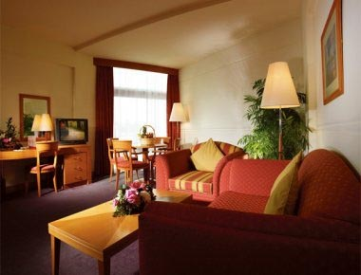
In Abu Dhabi SilverDoor currently represents four serviced apartments, all located in the business district. The newest addition is Beach Club apartments. Ideally located for either business or leisure the Beach Club apartments also have a stretch of pristine white beach within the Tourist Club area.
The UAE was established in 1971, following an agreement between rulers of the seven emirates to form a union. Abu Dhabi and Dubai being the most well known of the seven emirates. Dubai is considered the country's commercial capital and many blue chip companies have now set up regional headquarters in Dubai.
West Bay Apartments in Doha and Al Fateh Apartments in Bahrain are both located close to the business districts and offer a range of one, two and three bedroom apartments all with on site facilities. As with most Middle Eastern companies, Bahrain and Doha are still expanding and are heavily under construction with a major emphasis on business rather than leisure.
ENDS
About SilverDoor
SilverDoor international serviced apartments was incorporated as a Limited Company in March 2000 under its original name of Hotdigs. At the beginning of January 2006 the company changed its name to SilverDoor. The company was formed and continues to be led by managing director Marcus Angell. SilverDoor boasts an impressive client portfolio which includes many FTSE 100 such as RBS, HSBC, Cadburys Schweppes and MAN Group PLC.
SilverDoor has recently introduced new serviced apartments in Cardiff and some newManchester serviced apartments. SilverDoor offer serviced apartments in over 160 locations globally such as London, Paris, New York, Abu Dhabi and serviced apartments in Dubai.
SilverDoor is based in Chiswick, West London.
For further information, please contact:
Marnie Delaney-Parker
Head of PR and Marketing
SilverDoor
3 Dukes Gate
London
W4 5DX
07903 900 785
www.silverdoor.co.uk

