Silverdoor Announces Expansion In Database


Released on: May 19, 2009, 7:47 am
Author: SilverDoor
Industry: Real Estate
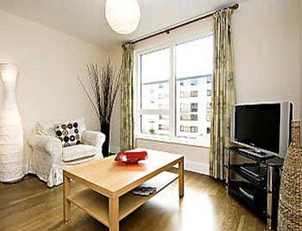
SilverDoor has announced that it has added to its extensive portfolio of accommodation by introducing new apartments in Cardiff and London.
Meridian Apartments are a range of studios, one and two bed serviced apartments in Cardiff. They opened in February 2009 and are located in Cardiff city centre, near to the Millennium Stadium and close to both Cardiff Central and Cardiff Queen Street rail stations. The apartments are housed within a purpose built building and boast luxurious bedrooms, bathrooms, living areas and kitchens.
Since 2005 when Cardiff celebrated its centenary as a city and 50 years as capital of Wales, "Cardiff serviced apartments are becoming more and more popular due to the regeneration of the bay area and key parts of the city centre," said Chris Gee, Sales Director at SilverDoor.
Another property recently added to the SilverDoor portfolio is Templeton Place in London, which is housed within a newly completed residential development in Earls Court. The apartments are conveniently located for Earls Court Exhibition Centre and the underground station, providing easy links for other parts of London. These serviced apartments in London offer a spacious, contemporary living area, with fully equipped kitchen and integrated appliances.
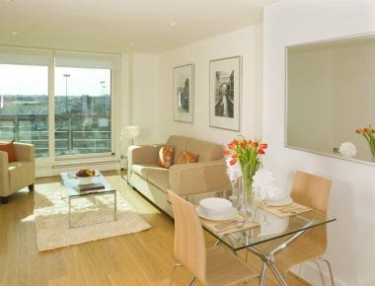
"This part of London is such a popular location. Trying to accommodate people who need to be near this area has been a challenge as we have not had enough serviced apartments here before. There are many apartment buildings in the surrounding areas but there weren’t enough in Earls Court and many have restrictions on lengths of stays, some with minimum stays of ninety nights. One of the benefits of Templeton Place apartments is that they will offer shorter stays," said Chris Gee. "We’re delighted that we can now offer something in this area and are confident it will become a huge success."
Also new in London is Gloucester Place Apartments in Marylebone. It is housed within a newly converted Georgian townhouse located less than five minutes walk from Regents Park and Baker Street underground stations. All of the one bedroom apartments have air conditioning, a fully equipped kitchen with a range of integrated appliances and a comfortable lounge and dining area.
"Marylebone is a really popular area for serviced apartments in London and we get many requests, especially from overseas visitors who intend to stay for a while," said Stuart Winstone, Head of Business Partnerships at SilverDoor. "The whole area has the feel of a small village to it and is so close to Regents Park offering the best of both worlds, yet is ten minutes walk from the hustle and bustle of Oxford Street and the West End."
ENDS
About SilverDoor
SilverDoor international serviced apartments was incorporated as a Limited Company in March 2000 under its original name of Hotdigs. At the beginning of January 2006 the company changed its name to SilverDoor. The company was formed and continues to be led by managing director Marcus Angell. SilverDoor boasts an impressive client portfolio which includes many FTSE 100 companies such as Cadbury, MAN Group PLC, ICAP and Serco Group.
SilverDoor offers serviced apartments in over 160 locations globally such as London, Paris, New York, Abu Dhabi and Dubai. SilverDoor has also just added a selection ofserviced apartments in Swindon and a selection of serviced apartments in Berlin to its portfolio.
SilverDoor is based in Chiswick, West London.
For further information, please contact:
Marnie Delaney-Parker
Head of PR and Marketing
SilverDoor
3 Dukes Gate
London
W4 5DX
Tel: 07903 900 785
www.silverdoor.co.uk

