Start-rite Launches Children’s Summer Shoe Collection

Released on: May 28, 2009, 4:00 am
Author: Start-rite shoes
Industry: Retail
With summer on the way, children’s footwear company Start-rite have launched their latest collection of kids shoes. Designedwith both child and parent in mind, the collection features styles children will adore with the durability and quality parents look for.
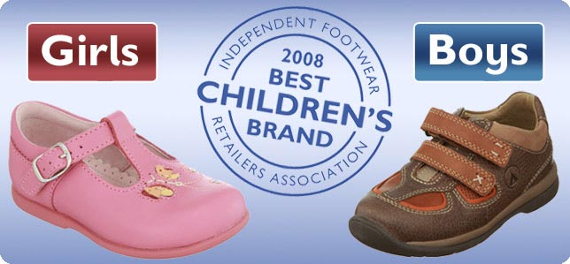
With three core themes incorporated into the collection, their new ‘Jamboree’, ‘Saharan Trail’ and ‘South Bank’ range to their children’s shoe collection are already proving popular. Start-rite have followed key trends for the season in this new range, such as camouflage an
d nautical inspired for the boys shoes, and boho and ethnic inspired designs for the girls shoes.
Their updated collection of canvas plimsoll styles combines practicality with fashion - the new boy’s design features a ‘space man’ theme, and the girl’s design features a ‘pop art’ theme.
Meanwhile, their sandal collection welcomes two new arrivals. ‘Pit Lane’ is a fun, navy sandal perfect for beach wear for boys, while ‘Saffron’ is a sorbet pink leather girls sandal with pretty flower features.
Start-rite have also included new light weight and robust children’s trainers in several colour schemes in the updated collection. New to the girls shoes range is the sporty ‘Go Girl!’ style with turquoise details, while the boys shoe range welcomes in Rubik’s cube inspired ‘Bounce’.
As the only brand that offers six width fittings available in half and whole sizes, Start-rite have become renowned for providing quality fitted children’s shoes. As well as offering more fittings than any other children’s shoe brand, Start-rite was the first children’s fitted shoe brand to launch an e-commerce site.
The brand is as dedicated to providing quality fitted children’s shoes online as they are offline. Their website is also a valuable resource for information about children’s foot care and features a downloadable foot measurement gauge to ensure customers order the correct fitting shoe for their child.
The importance of fitted shoes is clear - many experts blame adult foot problems as a result of wearing ill-fitting children’s shoes. Start-rite's free downloadable foot measure gauge means parents can accurately measure feet at home and purchase online with confidence.
Generations of parents have entrusted Start-rite with looking after their children’s feet in the UK, including the Royal Family. The company has earned its reputation as the nation’s best shoes’ for children, with a history spanning over 200 years. Last year Start-rite was honoured with the annual ‘Best Children’s Brand’ award by the Independent Footwear Retailers Association.
From school shoes and formal shoes to trainers and plimsolls, Start-rite continues to extend their range of kids shoes every season that appeal to the more fashion conscious parent and child, while still maintaining superior quality, fit and durability.
Start-rite’s collection of kids shoes are available across the UK and internationally in over 35 countries through over 400 retailers. Alternatively, their products can be purchased online on their website.
To see the latest collection of start-rite girls shoes, or to find out more about their downloadable foot measurement graph, visit http://www.startriteshoes.com.
Contact Details: Start-rite Shoes
http://www.startriteshoes.com
0844 561 7263
customer.services@start-rite.co.uk

