Arclab MailList Controller Version 7.2 available for Download

Released on: June 18, 2009, 7:08 am
Author: Arclab Software Technologies
Industry: Software
Arclab MailList Controller Version 7.2 available for Download
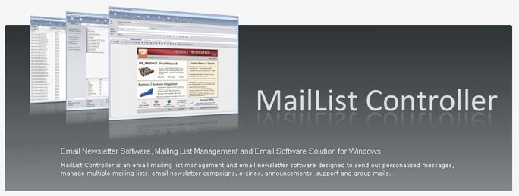
MailList Controller is an email mailing list management and email newsletter software designed to send out personalized messages, manage multiple mailing lists, email newsletter campaigns, e-zines, announcements, support and group mails.
MailList Controller works with Microsoft® Windows® 2000/XP/2003/2008/Vista/7.
Features of the latest version:
- Send out Newsletters to your Subscribers
- Fast SMTP Email Software Engine
- Works with any Mailaccount (SMTP/POP3)
- Supports SMTP/ESMTP Authentication
- Support for SSL and StartTLS (Secure Socket Layer)
- Partial and delayed Send Mode for limited Mailaccounts
- Directory Pickup Mode for direct mailing without SMTP
- Forward Replies to a different Email Address
- Customizable Returned Mail (Bounce) Detection
- Manage and Host multiple Distribution Lists
- Supports 15 custom Fields for Personalization
- Supports Filters and Subsets (Queries) for partial Mailing
- Linked Lists (List linked to an external Data Source)
- Single and Double Opt-in Subscriptions
- Process Email Subscribe and Remove Requests
- Process Webform Subscribe and Remove Requests
- Import and Export Members
- Sort out duplicate Email Addresses automatically
- Built-in WYSIWYG Rich-Text (HTML) Editor
- Support for external Mail Clients
- Direct support for external HTML Editors
- Personalization (Mail Merge)
- Add inline Graphics and File Attachments to Newsletter Messages
- Import HTML files from an external HTML Editor
- Send Plain Text, HTML or Messages in MIME Format
- Custom Charsets for international Newsletter Mailings
- Email Software that runs on your Computer
- Works on a Windows PC, Desktop, Laptop or Server
- No special Hardware or additional Software required
- No Subscription and no Recurring Fees required
The newsletter software is available in 3 different versions:
- MailList Controller Free (Freeware)
- MailList Controller Pro (99$)
- MailList Controller eXtreme (1994)
Website: http://www.arclab.com/products/amlc
About Arclab:
Arclab Software Technologies is a software development company creating and marketing windows applications for home and business users, founded in 1997, located in Regensburg, Germany.
Contact:
Arclab Software Technologies
Herbrig & Lappert GbR
Yorckstr. 22; D-93049 Regensburg; Germany
www.arclab.com
office@arclab.com

