Burton Black Label Providing Bags Of Style

Released on: June 1, 2009, 4:27 am
Author: Sara Scurfield
Industry: Apparel & Fashion
This season Burton, one of the leading men's clothes retailers in the UK, has launched an exclusive new limited edition Black Label premium brown leather luggage piece.
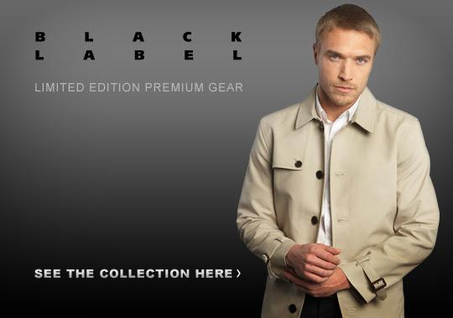
With only 50 pieces on sale, the limited edition brown leather holdall was picked up as one to watch right after the SS09 Press Show - months before its April release. Ideal for stylish summer weekends away, the new Black Label holdall is made from premium leather and is being made available exclusively in 12 Burton stores throughout the UK as well as online through the Burton website.
The new bag sees the quality dial increase even more with a selection of luxury leather and emphasis on detail - all keeping in line with Burton’s commitment to affordable luxury mens clothes at a retail price just under £100 . After the bag appeared in numerous dailies this past February, Burton responded by creating a waiting list on the site for those that want immediate notification when the bag is ready for sale.
As well as this new sought after holdall, the Burton Black Label collection is also entering into its exciting fourth season by increasing the attention to detail and subtle styling with a selection of luxury fabrics and key looks for the months ahead.
Stylish black and grey tipped jersey polos, luxury knitwear pieces and sophisticated Italian cotton shirts make up the new range, all of which emphasize the exclusivity and premium look of the Black Label mens fashion collection, and can be worn together or as a welcome addition to an existing wardrobe.
Notes to editors:
About Burton
Burton has a long history in mens clothing and fashion having been founded in 1903 by Montague Burton in Chesterfield. Burton now has over 400 outlets all over the UK and Ireland making it one of the country's largest sellers of casual and formal menswear, including jeans, shirts, jackets, mens t-shirts, suits, knitwear, mens shorts, shoes, underwear and accessories.
Customers can also shop online from the Burton.co.uk website which offers free returns in-store or by post and fast delivery to their home. The site features a useful size guide to ensure customers can get the correct fit. They can also sign up for the Burton newsletter, which offers all the latest style updates, exclusive discounts and competitions.
Burton PR Contact:
Sara Scurfield
Colegrave House
70 Berners Street
London
UK
W1T 3NL
020 7291 2951
www.burton.co.uk

