Burton launches Dad's Army t-shirts for Fathers Day


Released on: June 3, 2009, 11:21 am
Author: Burton
Industry: Apparel & Fashion
Burton, leading high street retailer of men's fashion, has launched a limited edition 'Dad's Army' t-shirt in conjunction with armed forces charity - the British Forces Foundation.
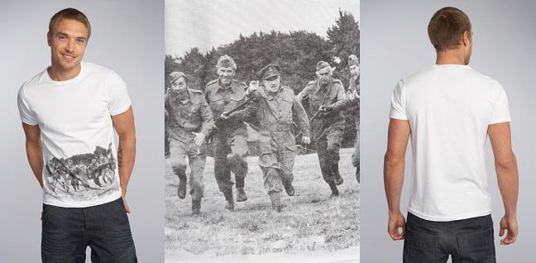
The new t-shirt has been designed to help support the British Forces Foundation, (BFF) and is being made available in 47 Burton stores and online. Burton, the mens fashionretailer, has pledged that for every one of the t-shirts, it will make a donation of £1.50 to the charity, in an effort to raise an overall donation of around £10,000.
The British Forces Foundation was set up in 1999 and aims to support all personnel currently serving in the army by providing them with quality entertainment to encourage high spirits and greater enjoyment of duty. The charity appeals to performing artists like musicians to travel to different countries and entertain soldiers, pilots and sailors while they are away from home.
Founded and still supported by the entertainer, Jim Davidson, the BFF has helped entertain women and men in the armed forces for the past 10 years and is now teaming up with Burton in an attempt to encourage more donations in honour of this year's Father's Day. The present initiative aims to support families where the fathers are in combat, around Father's Day, a time when the gap left by their absence can be felt especially hard by partners and children.
The new Burton's "Dad's Army" t-shirts will provide a fitting dedication to those men currently serving overseas who have families awaiting their return and it is hoped by Burton that the money raised for the charity will help to reduce the impact and feelings of separation which can be felt by the families of service men around Father's Day. Burton will also be offering a 10% discount to all customers with a valid MOD card in select stores until 31st July. Please see website for details and locations.
About Burton
Burton was originally founded in 1903 under the name The Cross-Tailoring Company. It quickly became popular and expanded into hundreds of outlets and factories across the United Kingdom. Today, it is a staple on most high streets and a popular retailer formens clothing, including tailoring, casual clothing and mens shoes shirts and jeans.
For further Burton media information, please contact:
Sara Scurfield
Colegrave House
70 Berners Street
London
UK
W1T 3NL
020 7291 2951
www.burton.co.uk

