DragonFire Racing Kawasaki Teryx Clinches Baja 500 Victory
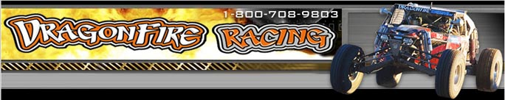

Released on: June 18, 2009, 6:55 am
Author: DragonFire Racing
Industry: Automotive
Kawasaki Teryx finishes miles ahead of competition to win at 41st Baja 500
MESA, Ariz., June 2009 -- DragonFire Racing, a leader in custom performance racing vehicles, accessories and custom racing, announced that its Kawasaki Teryx, driven by Reid Nordin of Team Green Kawasaki and co-driver Hans Waage, took first place in UTV class at the Baja 500, in Ensenada, Mexico. The first place finish was the first win ever for Kawasaki Teryx, in the Sportman UTV class of the Baja 500.
“It was the best racing we have had in Baja,” said Todd Romano, owner, DragonFire Racing. “A flawless day with only one mechanical repair, allowed us to run a safe and consistent pace all day. A broken rear upright cost us about three hours, but the speed of the DragonFire Teryx was able to put a big enough lead on the field to make up lost ground and still win by over an hour.”
Based in the racing hotspot of Mesa, Ariz., DragonFire Racing carries a large selection of vehicles, parts and accessories, for every level of enthusiast, from the most seasoned racers to weekend warriors. Vehicles includes sand cars and pre-runners to a range of ATV’s and Quads. DragonFire Racing also offers a range of parts covering everything from the engine to the wheels as well as a tie-down straps and winches. In addition, DragonFire Racing offers t-shirts and women’s apparel.
With a 10,000 square foot corporate facility and newly opened retail facilities in Lake Havasu City, Ariz. and San Diego, DragonFire Racing has grown to be a reliable and preferred solution for outdoor racing enthusiasts. For more information on the Yamaha Rhino 700 EFI or DragonFire Racing, please visit http://www.DragonFireRacing.com.
About DragonFire Racing
DragonFire Racing is a leader in custom racing performance parts and accessories forYamaha Rhinos Performance, Sand Rails, Pre-Runners, Arctic Cat Prowlers, Polaris rzr accessories, Kawasaki Teryx, Side X Side parts, and ATV Exhausts with headquarters in Mesa, Arizona. Focused on building performance accessories and turnkey race vehicles, DragonFire Racing delivers high performance parts and vehicles to customers and dealers worldwide. DragonFire Racing has franchises in California and Arizona. For more information, please visit the company's website at http://www.DragonFireRacing.com.
# # #
Contact Details: Todd Romano
DragonFire Racing
800-708-9803

