Drug Addiction Stories – Hot Topic on New Narconon Drug Rehab Blog
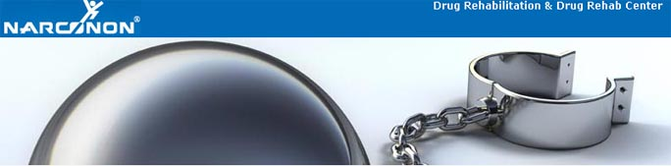

Released on: June 17, 2009, 5:48 am
Author: Narconon Drug Rehab
Industry: Healthcare
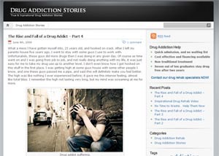
Trois-Rivieres, Quebec – Blogging has always been one of the best ways to get information out there, and let the whole world know what is on your mind. A new blog promoted by the Narconon Trois-Rivieres drug rehab program has been getting rave reviews for its unique content, accessibility, and over all image. The purpose of this blog is to keep getting the message out to millions of people about the effects drugs and alcohol can have on a person life. Everyday there are individuals struggling with drug and alcohol addiction. Thesedrug addiction stories give a detailed look into the life of those battling drug addiction. Some of these posts are based on true stories about drug addiction, and some of these stories on drug addiction are fictional, but are inspired on true events.
Every week there will be new short drug addiction stories posted, all telling a different tale about drug addiction. Every now and then there will be something based on a true story, or a testimonial, or account of someone’s life who has experienced drug addiction. These drug addiction stories are important, because they tell the stories of people experiencing the horrors of a drug or alcohol addiction. The Narconon drug rehab program has been publishing real life stories and videos of real people overcoming addiction for many months now. It is important for those who are battling addiction to see that it is very possible to overcome addiction, and beat it for good.
Every addict and former addict has a story to tell, some of these stories are inspirational, and some of these stories are quite sad. There is always a message to be delivered; drug and alcohol abuse has the potential to take so much away from a person. Everyday there are more people suffering from addiction, and some of these addicts gave up hope that they can get out of their drug or alcohol addiction. If you or someone you know is battling a drug or alcohol addiction, call our toll free number at, 1-877-782-7409, or visit us at, http://narcononrehab.com/
© 2009 Narconon Trois-Rivières. All Rights Reserved.
NARCONON is a trademark and service mark owned by Association for Better Living and Education and is used with its permission.

