International Oddities, Number One Retailer For Legal Herbal Smokes

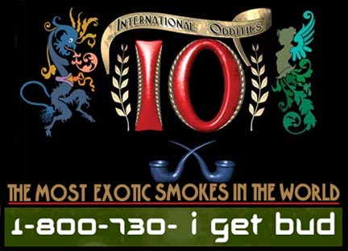
Released on: June 9, 2009, 7:16 am
Author: Internationaloddities.com
Industry: Retail
A revolutionary player in the tobacco, cigarette, cigar and smoking industry, International Oddities is a 100% legal herbal smoke company. Selling wholesale to distributors and stores and also selling products on their own on the web, the company has become an influential player worldwide. While initiating the legal bud industry, the company's most popular products are sold in some of the largest tobacco and smoke shop chains in America and worldwide.
The first company to offer legal bud, International Oddities had viable legal herbal smokes decades before anyone else in the industry even tried to replicate the same products. Their competitors today only have a chance at it because of the worldwide appeal IO has achieved with their products. Today, the best their competitors can do is provide hard golf ball size lumps of herbs which many smokers have deemed unsmokeable.
International Oddities however offers customers a chance to peek-a-bud through the window of their “Freshpack Rolling Kit” before purchasing. This ¼ oz. kit includes built-in rolling papers and a retractable rolling tray. Their 1 oz. cans are vacuum packed making them fresh for a long period of time. With a 360 degree view of the enclosed ½ oz. packaged buds in their patented “shotgun tubes”, these legal herbs customers can be certain of the quality they are getting before paying for it.
By working directly with farmers and growers worldwide, each of the legal herbal smokes exotic products are crafted from seed to smoke to be high quality. This increases the enjoyable and relaxing atmosphere shared when partaking of legal herbs from International Oddities. As no tobacco is found in the products, the company is one of the first to provide a viable alternative to smoking the same old thing. While offering the most intriguing smoking experience imaginable, these products are widely accepted as preferable for the smoker and the environment.
While popular in the counterculture and Hollywood, regular consumers enjoy these products as well. With the growing debate of legal marijuana, the public's awareness of legal herbs like those offered by International Oddities has been gaining in popularity. This wide acceptance can be found in the mass media. Some of International Oddities' products have been used in Pineapple Express, True Blood, and Crash with Dennis Hopper, CSI and My Name Is Earl.
Other influences on the world have included the recent making of tobacco illegal in Amsterdam; this caused them to ask the company for an herbal smoke solution. With a Masters Series nicotine-free tobacco alternative available, products such as Rembrandt's Brand, Van Gogh's Blend and Shakespeare's Blend are now available.
With constant changes in their products and the increase of their already superior quality, International Oddities offers dozens of legal herbs products that are more interesting than mere tobacco. With a unique experience for those who smoke or have smoked in the past, these legal herbal smokes are the new thing.
About Internationaloddities: For more information on legal herbs or herbal smoke shops, visit their official website, internationaloddities.com. More information can also be provided by phone at 1-800-730-4438. Enjoy legal herbal smokes today! It's an experience that is unforgettable.
Contact Details: http://www.internationaloddities.com
1-800-730-4438
P.O Box: 6009433
CA 90630
US

