Naartjie Announces the Arrival of Its Fall Transition Collection


Released on: June 18, 2009, 7:36 am
Author: Naartjie
Industry: Apparel & Fashion
All spring and summer fashions on sale for less than $20
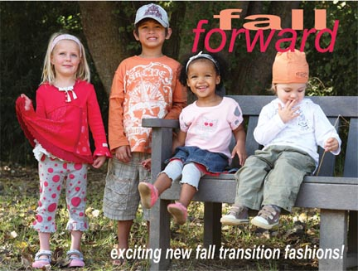
SALT LAKE CITY, Utah, June 2009 -- Naartjie, the original name in fashionable, kid-friendly clothing, today announced the arrival of its Fall Transition Collection designed to outfit youngsters as they breeze from summer into milder weather. The Fall Transition clothing features season-appropriate fabrics, colors and styles, bridging summer-to-fall while accommodating the warmer Indian summer days.
“Late summer marks a transition from the long, endless days of summer, into the cooler signs of fall, however, it doesn’t mean the fun has to end,” said Joe Norwood, director of marketing, Naartjie USA. “With our newest Fall Transition Collection, kids can dress for the occasional warm fall day, even after they have long outgrown last season’s summer clothing.”
Inspired by modern shapes and colors, the new girls’ and infants’ Fall Transition lines feature playful spotty prints combined with soft, speckle floral prints to wear on summer nights or to layer with weightier fabrics in the cooler months ahead. Made from 100 percent cotton, the knit group has touches of netting to add whimsy and a playful look. Always easy to wear and easy-to-care for, this collection represents the best qualities of summer and fall.
Explorers of the past inspire the new boys and baby boys Fall Transition clothing. Incorporating the myths of the sea as told by sailors recounting sea monsters, and combining the historical 1492, this collection is a playful reflection of nautical exploration in the days of old. Pirates, skeletons and old masts decorate the all cotton pieces designed to be worn separately or layered for fall dressing.
Newborn get a chance to flaunt these fun and modern pieces with newborn girls featuring Speckle Floral print combined with soft yarn and playful shapes that make a great gift ensemble and everyday wear. A retro car theme inspires the newborn boys line with the use of red and grey block stripes for a bold, new look. Summer-to-fall transition is made easy with sleeveless and layering pieces.
Naartjie designs, colors, prints, and styles represent a truly unique synthesis of European fashion trends with western casual lifestyle. Featuring a dominant focus on natural fabrics that are garment-dyed, pre-washed and pre-shrunk for easy wear, low maintenance and comfort, Naartjie uses a garment dye process that results in a more vibrant color and softer clothing and accessories for precious little ones.
The ultimate in mix and match, Naartjie introduces new colors, prints and styles within a monthly grouping to allow customers to mix and match across the entire assortment. In addition, shoppers can mix and match between Naartjie collections, which showcase the freshest and broadest color assortment in the industry, distinctive detailing, mixing of fabrics, appliqués and embroidery details. Always “Kid-Friendly” design concepts made primarily of natural fabrics that feature weight-right fabrications for maximum comfort and easy care. Each item is designed and constructed for easy-wear comfort, whether the garment is dressed up or dressed down.
About Naartjie
Naartjie was founded in 1989 in Cape Town, South Africa when designer Anne Eales sought an alternative to the limited selection of childrens clothes available as she shopped for her three young boys. From its very conception, Naartjie was about KIDS… playful, vibrant, active, colorful, natural, always changing. We offer great kids clothesand baby clothes , basics and accessories for girls, boys, and newborns to 10 years of age -- all at surprisingly affordable prices. Naartjie’s corporate headquarters are located in Salt Lake City, Utah. Naartjie owns and operates stores in both the United States and South Africa, with new stores opening regularly. For more information, please visit us at http://naartjie.com.
# # #
Contact Details: Joe Norwood
Naartjie
2369 West Orton Circle
Salt Lake City, UT 84119
801-977-7790

