Organic Baby Clothing Makes the Perfect Baby Gift
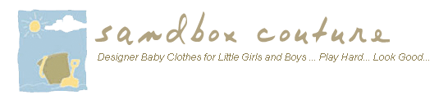

Released on: June 30, 2009, 4:56 am
Author: SandboxCouture.com
Industry: Retail
Sandbox Couture offers this season’s most desirable baby clothing and baby gifts made of eco-friendly organic bamboo and soy
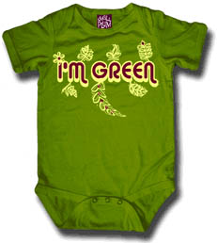
Rancho Santa Margarita, Calif., June 29, 2009 -- Sandbox Couture.com, a leading online children's boutique specializing in baby clothes and baby gifts, introduces organic baby clothing for girls, boys and infants. SandboxCouture.com offers hip, stylish children’s clothing including organic baby clothes from Baby Star and Small Plum, and a selection of environmentally friendly baby gifts made of organic bamboo and organic soy cotton.
"Everyone loves shopping for babies and baby gifts, but because parents are very selective when it comes to baby products, going organic is often the wisest choice when buying gifts for infants and children," said Sam Brown, spokesperson for Sandbox Couture. “Choosing gifts made of organic and eco-friendly materials, free from aldehyde-based dyes, is a thoughtful gift-giving gesture, and thanks to the variety of organic baby products we carry -- no more boring white onesies.”
Shoppers will find an array of organic baby clothing and baby gifts perfectly suited to any occasion. Be it a baby shower, christening or birthday, customers looking for the ultimate parent-pleasing baby gift will end their search at Sandbox Couture. Itzy Ritzy nursing covers, blankets and car seat covers in fun, formaldehyde-free prints make ideal baby shower gifts. Soy organic cotton baby clothing, blankets and accessories, in eye-catching designs are sure to please. Small Plum Organic Bamboo graphic t-shirts and one-piece outfits are designed for kids who want to make a statement, while matching yoga pants keep kids comfortably bedecked in complementary colors.
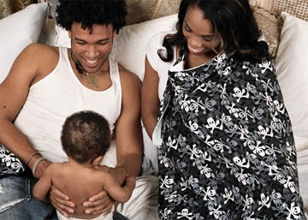
Organic Bamboo is one of the world's most sustainable resources. It is the fastest growing grass on the planet. Bamboo grows organically without fertilizers, pesticides or irrigation, while absorbing greenhouse gases and converting them to green growth. Its fabric is hypoallergenic, thermal regulating and has fast drying, anti-microbial properties. In addition, bamboo wicks water up to four times faster than cotton, is odor resistant and provides UV ray protection.
Known as the source for quality children’s clothes and couture fashions for babies and children, Sandbox Couture has provided busy parents -- and a loyal following of couture shoppers and celebrity moms -- a convenient outlet for quality, value and fashion savvy designs for little boys and little girls. Sandbox Couture has developed a reputation for offering couture children’s fashions, at prices that parents will appreciate. From unique designs to the hottest trends, Sandbox Couture's collection of designers offers the convenience of online shopping and the benefits of online savings.
Sandbox Couture is now serving the global community with its fashion forward trends and name brand selections. International shipping rates apply. For additional details, please visit www.sandboxcouture.com.
About Sandbox Couture
Sandbox Couture is an online children's boutique retailer, providing baby clothes, baby gifts and unique children’s clothes. The company takes pride in hand selecting products from top designers, thereby ensuring quality and contemporary style. Sandbox Couture’s philanthropic contributions and socially conscious business practices are at the forefront of the company’s ideals and corporate culture. Founded in 2005, Sandbox Couture is privately held and headquartered in Rancho Santa Margarita, CA. For information about Sandbox Couture, please visit the company's web site at http://www.SandboxCouture.com.
###
Contact Details: Sam Brown
949-459–2505
pr@sandboxcouture.com

