SilverDoor Expands Throughout The UK With More Serviced Apartments


Released on: June 9, 2009, 4:09 am
Author: SilverDoor
Industry: Real Estate
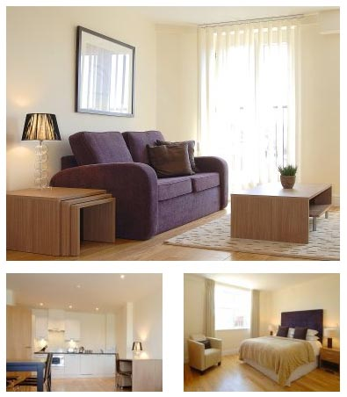
SilverDoor adds the first ever purpose built serviced apartment development in Cardiff to its ever increasing portfolio.
SilverDoor has added the first ever purpose built development of Cardiff serviced apartments to strengthen its portfolio of UK serviced apartments and has also added more serviced apartments in Reading and more serviced apartments in Brighton.
Crown Apartments in Reading offer one and two bedroom accommodation and are just a few minutes' walk from the town centre and the rail station. A great selection of shops, restaurants and bars can be found in the town centre along Broad Street and within the Oracle Shopping Centre. These apartments are modern and luxuriously furnished and well suited for business travellers and are in a convenient position for all of Reading's blue chip companies.
Also added last year to the SilverDoor database is Loft Apartments in Brighton. These apartments are a selection of luxuriously furnished one and two bedroom apartments and are conveniently located to enjoy the vibrant nightlife, shopping and café culture of Brighton. Each apartment has been decorated in a modern style and includes a fully equipped kitchen, comfortable living area and a separate bathroom with a bath and shower. Some of the apartments also have access to a private rooftop terrace with sea views.
"These locations are very popular for SilverDoor and the serviced apartment market and we're delighted that we now have some more options to offer," said Chris Gee, sales director at SilverDoor, "The provider we use in these locations also has serviced apartments in Glasgow and Bristol, again very popular locations for us."
A new addition, opened earlier this year is Meridian Apartments in Cardiff. These serviced apartments provide modern serviced accommodation and are housed within a purpose built development with a choice of studios, one and two bedroom apartments. All of the apartments are tastefully furnished and come complete with state-of-the-art kitchen facilities, comfortable living areas and luxurious bedrooms with king size beds and modern bathrooms. The development also has a reception desk manned throughout office hours.
"We are finding that more and more companies are opting for serviced apartments over hotels so availability can be limited so to get a provider to invest into key locations and with high quality accommodation is just perfect," said Marnie Delaney-Parker, head of PR and marketing at SilverDoor.
SilverDoor offers serviced apartments in more than 160 locations globally and offers a range of accommodation to suit all budgets.
ENDS
About SilverDoor
SilverDoor International Serviced Apartments was incorporated as a limited company in March 2000 under its original name of Hotdigs. At the beginning of January 2006 the company changed its name to SilverDoor. The company was formed and continues to be led by managing director Marcus Angell.
SilverDoor boasts an impressive client portfolio which includes many FTSE 100 companies such as Cadbury, MAN Group PLC, ICAP and Serco Group as well as relocation and hotel booking agents.
SilverDoor offers serviced apartments in more 160 locations globally such as London, Paris, New York, Abu Dhabi and Toyko. SilverDoor has also just added to its portfolio with some new serviced apartments in Paris and a selection of Swindon serviced apartments to its portfolio.
SilverDoor is based in Chiswick, West London.
For further information, please contact:
Marnie Delaney-Parker
Head of PR and Marketing
SilverDoor
3 Dukes Gate
London
W4 5DX
07903 900 785
www.silverdoor.co.uk

