SilverDoor Increases Northern Property Portfolio

Released on: June 29, 2009, 4:56 am
Author: SilverDoor
Industry: Real Estate
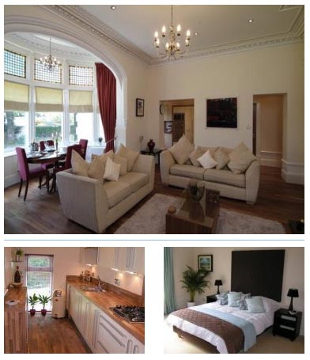
SilverDoor has announced new additions to its portfolio of properties in northern England, with several apartments in Liverpool.
The Hall Street serviced apartments in Liverpool are in a Grade II listed building located in Central Liverpool, not far from the Albert Docks, the Tate Liverpool and the Maritime Museum. These two bedroom apartments provide comfortable serviced accommodation and consist of one double bedroom, one twin bedroom, a bathroom, a fully integrated kitchen and a lounge with a dining area.
Also new to the SilverDoor portfolio is Keel Wharf Apartments, located in the Docks area of Liverpool. It offers a selection of studios and one bedroom apartments and all are furnished with a full kitchenette, a work area and a comfortable lounge/dining area.
Since winning the accolade of the European Capital of Culture in 2008, Liverpool has seen a lot of regeneration and the Docks area of the city is now a haven of bars, restaurants and cafes.
Marnie Delaney-Parker, Head of PR and Marketing for SilverDoor said: "For the guests who are more used to a hotel, then Keel Wharf Apartments work brilliantly as they have the benefits of a hotel with the space and comfort of a serviced apartment."
SilverDoor has also added further serviced apartments in Cardiff to its database with the addition of the Ocean Building Apartments situated in the trendy Cardiff Bay area of the city.
About SilverDoor:
SilverDoor International Serviced Apartments was incorporated as a limited company in March 2000 under its original name of Hotdigs. At the beginning of January 2006 the company changed its name to SilverDoor. The company was formed and continues to be led by managing director Marcus Angell.
SilverDoor boasts an impressive client portfolio which includes many FTSE 100 companies such as Cadbury, MAN Group PLC, ICAP and Serco Group as well as relocation and hotel booking agents.
SilverDoor offers serviced apartments in over 170 locations globally such as London, Paris, New York, Abu Dhabi and Tokyo. SilverDoor has also just added to its portfolio with additional new London serviced apartments and a selection of serviced apartments in Dubai to its portfolio as well as new serviced apartments in Manchester.
SilverDoor is based in Chiswick, West London.
For further information, please contact:
Marnie Delaney-Parker
Head of PR and Marketing
SilverDoor
3 Dukes Gate
London
W4 5DX
07903 900 785
www.silverdoor.co.uk

