SilverDoor Provides Alternatives To Second Homes For MPs
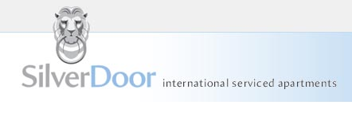

Released on: June 11, 2009, 5:57 am
Author: SilverDoor
Industry: Real Estate
SilverDoor has spoken out on the MPs' second home scandal with recommendations for alternative accommodation.
Rather than take on a second home in the capital, MP’s could take a serviced apartment and SilverDoor has taken on some new serviced apartments in London. West End Quay apartments are located in Paddington and are part of the Paddington Waterside development which is set around the Grand Union Canal. The location offers excellent access to the City and the West End from Edgware Road Underground stations while the Heathrow Express operates from nearby Paddington Station every 15 minutes. The modern and stylish studio, one and two bedroom apartments provide spacious living areas and quality furnishings and feature separate dining, living and sleeping areas. There is also a 24 hour concierge service and a courtyard seating area.
Birmingham, Manchester and Edinburgh have also been in the spotlight recently. Andrew Mitchell, Birmingham MP, claimed for furniture for his second home in Birmingham yet had the furniture delivered to his London home - something that could have been avoided if he had used a serviced apartment in Birmingham. The Arc Apartments are a new addition to SilverDoor’s serviced apartments in Birmingham. Located in the centre of the city, each open-plan one or two bedroom apartments is furnished to a high standard and features the use of a concierge service as well as complimentary broadband and on-site parking. "The Arc Apartments are in a perfect location for someone wanting to stay in Birmingham, whether it be for a short time or an extended stay" said Marnie Delaney-Parker, head of PR and marketing at SilverDoor.
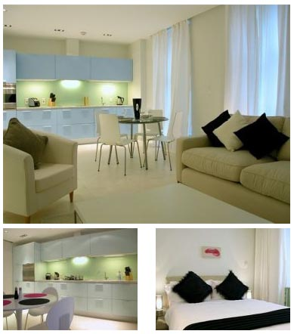
In Manchester, SilverDoor has numerous serviced options and The Edge apartments are located in one of Manchester’s most significant residential developments situated on a key riverside location in the city. The apartments offer a stylish spacious lounge/dining area and a fully equipped kitchen with a range of integrated modern appliances. Guests will benefit from free internet use and a welcome pack on arrival as well as on-site parking. These serviced apartments in Manchester complement the rest of the SilverDoor portfolio.
Clive Betts, Labour MP for Sheffield claimed over £6000 for furnishings of his second home, again a cost that could have been avoided, had he used a serviced apartment.
Recently added to the Edinburgh portfolio is Grove Executive. Opened earlier this year, the development includes a choice of studios, one and two bedroom apartments and two bedroom penthouses. These modern serviced apartments in Edinburgh city centre are located within the West End district and are a short walk from Princes Street, Edinburgh Castle and the mainline train station. John Barrett, Liberal Democrat MP for Edinburgh West claimed £1138 per month mortgage interest on a second home in a building in London where SilverDoor represent serviced apartments.
About SilverDoor
SilverDoor international serviced apartments was incorporated as a Limited Company in March 2000 under its original name of Hotdigs. At the beginning of January 2006 the company changed its name to SilverDoor. The company was formed and continues to be led by managing director Marcus Angell.
SilverDoor boasts an impressive client portfolio which includes many FTSE 100 companies such as Cadbury, MAN Group PLC, ICAP and Serco Group as well as relocation and hotel booking agents.
SilverDoor offers serviced apartments in over 160 locations globally such as London, Paris, New York, Abu Dhabi and Dubai. SilverDoor has also just added a selection of new Brussels serviced apartments and a selection of serviced apartments in Berlin to its portfolio.
SilverDoor is based in Chiswick, West London.
For further information, please contact:
Marnie Delaney-Parker
Head of PR and Marketing
SilverDoor
3 Dukes Gate
London
W4 5DX
Tel: 07903 900 785
www.silverdoor.co.uk

