SilverDoor Sees Growth In Larger Serviced Apartments


Released on: June 5, 2009, 8:13 am
Author: SilverDoor
Industry: Real Estate
SilverDoor increases its portfolio with larger apartments due to client demand.
Generally the trend in serviced apartments has been either one or two bedroom apartments and the larger apartments have been for training groups or perhaps relocation with a family, but SilverDoor has seen a recent growth in the need for larger apartments of three and four bedrooms.
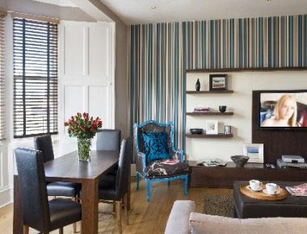
"Companies can reduce accommodation costs by getting colleagues to share a serviced apartment rather than booking three separate hotel rooms," said Marnie Delaney-Parker, head of PR and marketing at SilverDoor, "It’s not just the accommodation costs that are reduced but also all additional costs such as costly restaurant bills and laundry bills. All serviced apartments feature facilities to allow guests to cook for themselves and to do laundry. We estimate that for a longer stay, guests can save around 30% on additional costs compared to staying in a hotel."
SilverDoor has seen significant growth in Scotland and offers some larger serviced apartments in Glasgow. Central Apartments are housed in a refurbished Victorian townhouse and offer modern furnished accommodation in a fantastic city centre location. As well as offering three bedroom apartments, the property also has one and two bedroom options. All apartments are stylishly decorated and comfortably furnished while still retaining many original features.
Serviced apartments in Belfast have also seen a growing trend recently in larger apartments. Willowbank apartments in South Belfast offer two and three bedroom accommodation and have full kitchen facilities, a separate lounge area and a garden area, too. The apartments are a ten-minute drive from the airport as well as a short taxi ride from the city centre.
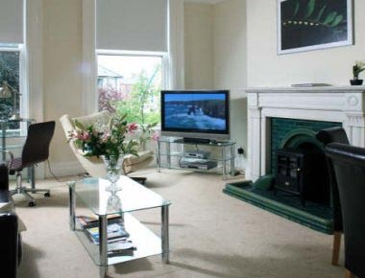
It's not just in the UK that SilverDoor has spotted a trend, with Amsterdam serviced apartments becoming larger to meet demand of clients wanting to share and save costs. Dutch Masters Apartments located within the city centre form part of an exclusive development within the historical district.
The development is situated on the Keizersgracht canal, and there are plenty of shops, bars, restaurants and transport connections nearby. Each apartment is themed on a famous Dutch artist to offer guests a variety of truly unique apartments.
The development offers one, two and three bedroom apartments, all comfortably furnished. Some apartments have a roof terrace, while some have access to the tranquil gardens at the back of the property and others have views of the canal.
ENDS
About SilverDoor
SilverDoor International Serviced Apartments was incorporated as a Limited Company in March 2000 under its original name of Hotdigs. At the beginning of January 2006 the company changed its name to SilverDoor. The company was formed and continues to be led by managing director Marcus Angell.
SilverDoor boasts an impressive client portfolio which includes many FTSE 100 companies such as Cadbury, MAN Group PLC, ICAP and Serco Group and relocation and hotel booking agents.
SilverDoor offers serviced apartments in more than 160 locations globally such as London, Paris, New York, Abu Dhabi and Dubai. SilverDoor has also just added to its portfolio with some new serviced apartments in Edinburgh and a selection of Nottingham serviced apartments.
SilverDoor is based in Chiswick, West London.
For further information, please contact:
Marnie Delaney-Parker
Head of PR and Marketing
SilverDoor
3 Dukes Gate
London
W4 5DX
07903 900 785
www.silverdoor.co.uk

