Spot and Leo


Released on: June 29, 2009, 6:03 am
Author: Melinda Franklin/Tiny Tot Boutique
Industry: Retail

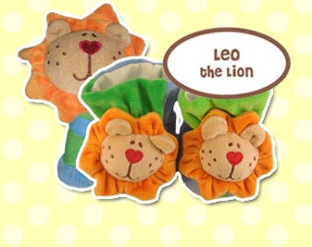
Tiny Tot Boutique would like to take this opportunity to congratulate Max Daniel Designs and owner Eden Amir on their recently launched new product line – Spot and Leo. Thisnew line features affordable baby booties (0 – 6 months) and rattles (birth and up) with a whimsical design for today’s trendy baby. The booties and rattles currently come in 8 new designs; Lady the Bug, Klaus the Mouse, Betty the Bunny, Spot the Dog, Candy the Cow, Leo the Lion, Jazzy the Giraffe and Snowy the Bear. And the booties even come in an adorable gift-giving keepsake box. Spot and Leo products are sure to be as big a hit as Max Daniel Designs award winning Max Daniel Baby throws and security blankets that are loved by all of today’s Hollywood Celebrities and their children. It’s rumored that Ben Affleck and Jennifer Gardner’s daughter Violet is rumored to have at least 5 of the Max Daniel Baby Rosebud and Satin throws.
Max Daniel Baby was awarded the Disney’s prestigious ‘IParenting’ Media Award in 2008. And both the Max Daniel Baby and Spot and Leo lines comply with the CPSIA.
For more information on Spot and Leo or Max Daniel Baby products you can visit Tiny Tot Boutique at www.tinytotboutique.com for a complete selection of all of these baby items from Max Daniel Designs.
Tiny Tot Boutique is an upscale baby boutique that has been in operation since 2007 committed to outstanding customer service and dedicated to offering today’s top brands.
Max Daniel Designs founded in 2004 is a woman owned and operated company known for
its luxurious and chic baby blankets and decadent adult animal print throws is a winner of Disney's prestigious iParenting Media Award.
Contact Details: www.tinytotboutique.com
813-957-1721
melinda@tinytotboutique.com

