Whether You Are Considering A Tummy Tuck, Liposuction, Breast Enlargement Or A Face Lift, We Are Able To Arrange Cosmetic Surgery Expertise


Released on: June 8, 2009, 6:31 am
Author: Beautiful Beings
Industry: Healthcare
We are committed to arranging cosmetic surgery and Gastric Band surgery for you at an affordable price. The cosmetic surgery clinic in Prague offers the latest cosmetic surgery and non surgical treatments. We are able to arrange cosmetic surgery for both men and women using the most up to date range of treatments. The plastic surgeons at the clinic in Prague are highly experienced, qualified and innovative.
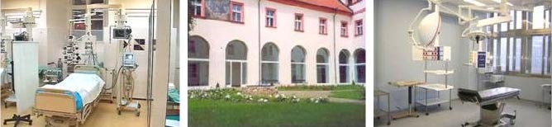
Prague is fast becoming the 'cosmetic capital' of Europe. The Czech Republic has a long tradition of plastic surgery. Professor Francis Burian, a Czech, is regarded as one of the pioneers in the field of plastic surgery. Charles University, Prague was home to Europe's first faculty for plastic surgery opening in 1920.
With plastic surgeons having to study for their medical degree, then having to practice general surgery first which is followed by 5 years of plastic surgery. You can be assured that your surgeon is not only qualified but experienced too.
Cosmetic surgery is becoming increasingly popular with both men and women. Some of the most requested cosmetic surgery are tummy tuck with liposuction, breast enlargement and eyelid surgery. Enquiries from men in particular are increasing as cosmetic surgery becomes both more affordable and acceptable. Cosmetic surgery is an option people choose for varying reasons. Whether it be a requirement for a tummy tuck with liposuction after child birth. Eyelid surgery to improve appearance to give a younger, fresher look or nose reshaping. At Beautiful Beings we can arrange your cosmetic surgery for you.
Contact Details: 10 birch road, onehouse, stowmarket, suffolk ip14 3ez 0844 88 44 77 0 olivia@beautifulbeings.co.uk

