Win £1000 To Spend At Astleyclarke.com


Released on: June 15, 2009, 4:59 am
Author: Astley Clarke
Industry: Apparel & Fashion
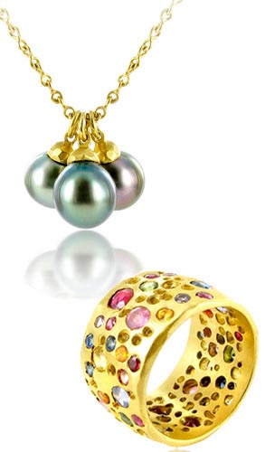
To celebrate Coutts London Jewellery Week June 8-14, Astley Clarke is offering the chance to win £1000 to spend on designer jewellery from AstleyClarke.com. The luxurious fine jewellery boutique Astley Clarke, to whom provides the most gorgeous pieces ofdesigner jewellery and fine jewellery from around the world including unique designer engagement rings and stunning diamond eternity rings, carefully chosen with one eye on the hottest looks of the moment and the other on timeless style. Astley Clarke has been classed as the destination boutique for buying the most lavish of jewellery gifts.
This past week saw one of the most prestigious events in the jewellery industry, London Jewellery Week. London Jewellery Week is an event that sees the industry’s most talent designer and some wonderful show cases, and this year was no exception. Throughout the week, 100 events were set to take place from north to south, east and west of London. All Leading British jewellers and retailers gathered to view and show case the latest industry designs.
Astley Clarke provided a show case at the discreet terraced side street off the Edgeware Road, displaying a new collection by fashion designers Osman Yousefzada, Carolina Bucci, Pippa Small, Vinnie Day, Kiki McDonough, Asha by ADM, Missoma and Monica Vinader. In particular, designer of the moment Osman Yousefzada known for contemporary colors and futuristic cuts on the catwalk presented four limited-edition pieces.
Online jewellery boutique Astley Clarke has truly embraced London Jewellery Fashion Week this year by offering the exciting opportunity to win £1000 worth of Designer Jewellery. Astley Clarke is currently show casing the most popular design by designers of the moment. Astley Clarke always makes sure to provide a truly unique combination of jewellery. The fine jewellery and designers alike have been carefully selected by the expert team, handpicking over forty designers. Designers that include the ever popular Osman Yousefzada, Carolina Bucci, Pippa Small, Vinnie Day, Kiki McDonough, Asha by ADM, Missoma and Monica Vinader and many more.
This one off competition is a way for Astley Clarke to show their appreciation and what’s more, to give a little back to their customers, old and new. The entry deadline for this exciting competition of winning £1000 to spend on select designer jewellery closes on the 21st June. Entrants must be 18 and over and resident in the UK. The winner will be notified by email or telephone shortly after and no later than 6th July 2009, the winner will be drawn electronically after the closing date. Furthermore the prize must be claimed within 28 days.
Contact Details: 0845 680 6848
6 Junction Mews, London W2 1PN

