Maastricht University And PharmaCell Publish Results On Possible Improved Immune


Released on: January 19, 2010, 6:58 am
Author: R. Hesselink
Industry: Biotech
In a collaborative publication in the prestigious journal Blood that appears this week, PharmaCell BV, the Maastricht University, Institute for Research in Biomedicine in Switzerland and the Research Center for Allergy and Immunology in Japan present data on a novel approach to improve treatment of acute leukemia patients. In a study that received a grant from the Dutch governmental organization SenterNovem, the consortium has shown that hematopoetic stem cells, commonly used in the treatment of those patients, can be cultured such that they show clear signs of an improved capacity to repair the immune system.
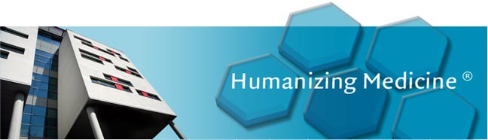
Patients suffering from acute myeloid leukemia can be cured by hematopoetic stem cell transplantation, but many viral or bacterial infections occur after the treatment and are life threathening. The protocol developed by the consortium can potentially reduce the period after treatment that the patient is susceptible to such opportunistic infections.
The proposed treatment may greatly reduce morbidity and mortality in those patients. In the study that was conducted in mice, it was found that the stem cells treated with their protocol quickly migrated specifically to the thymus and matured there into effector cells of the immune system. Further research is needed to delineate the precise mechanism of action and to prepare the technique for application in patients.
Alexander Vos, CEO of PharmaCell comments: “The outcome of this projects shows the strength of consortia in which academia collaborates with industry. It has enabled us to keep a focus towards clinical application in a research project that had fundamental questions. As a company that focuses on the development and production of cell therapies, this research fitted very well in our profile. We are very pleased with the collaboration as well as with the outcome. PharmaCell intends to closely follow future developments in this project and will expertly support future clinical application of this cell therapeutic application where possible.”
Dr. Gerard Bos, who together with Dr. Wilfred Germeraad,is the lead investigator of the Division of Heamatology, Department of Internal Medicine of the Maastricht University Medical Center+ announces: “We believe that the potential of this technique to improve patient care is high. Further research is needed before application in patients is possible, but we feel very confident about that. The research has been carried out by a very strong international group of scientist and the results are convincing. We are looking forward to further developing the method.”
The paper, in which the technique and its outcome are presented, is published in January 14 issue of Blood.
Contact Details: Reinout Hesselink Ph.D. or:
Manager R&D
PharmaCell B.V.
Oxfordlaan 70
The Netherlands
R.Hesselink@Pharmacell.nl
Tel. +31 (0)6 46 7369 16
www.pharmacell.nl

~~~~~

Press release distributed via EPR Network (http://express-press-release.net/submit-press-release.php)

