MailList Controller Version 8 Released


Released on: February 15, 2010, 7:28 am
Author: Arclab Software Technologies
Industry: Software
Arclab Software Technologies, a software development company creating and marketing windows applications for home and business users, announced today the release of the newest version of the professional email newsletter software "MailList Controller" version 8.
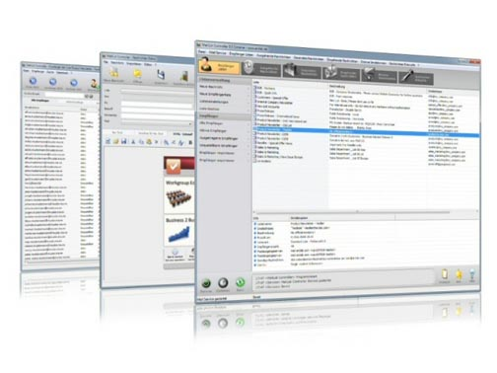
Arclab MailList Controller is an email mailing list management, bulk mail, email marketing and email newsletter software solution for windows designed to send out personalized email messages, manage multiple mailing lists, email newsletter services, campaigns, e-zines, announcements, support and group mails.
MailList Controller works with Microsoft® Windows® 7/Vista/XP/2000
Features of the latest version:
* Send out Newsletter and Bulk Email Messages
* Fast SMTP Email Software Engine
* Works with any Mailaccount (SMTP/POP3)
* Supports SMTP/ESMTP Authentication
* Support for SSL and StartTLS (Secure Socket Layer)
* Partial and delayed Send Mode for limited Mailaccounts
* Directory Pickup Mode for direct mailing without SMTP
* Forward Replies to a different Email Address
* Customizable Returned Mail (Bounce) Detection
* Manage and Host multiple Distribution Lists
* Supports 15 custom Fields for Personalization
* Supports Filters and Subsets (Queries) for partial Mailing
* Linked Lists (List linked to an external Data Source)
* Single and Double Opt-in Subscriptions
* Process Email Subscribe and Remove Requests
* Process Webform Subscribe and Remove Requests
* Import Members from MS Excel, MS Access, Text (csv) or ODBC
* Global Blacklist for Import and incoming Messages
* Sort out duplicate Email Addresses automatically
* Built-in WYSIWYG Rich-Text (HTML) Editor
* Support for external Mail Client (e.g. MS Outlook)
* Direct support for external HTML Editors
* Personalization (Mail Merge)
* Add inline Graphics and File Attachments to Newsletter Messages
* Import HTML files from an external HTML Editor
* Send Plain Text, HTML or Messages in MIME Format
* Custom Charsets for international Newsletter Mailings
* Subscribe Archive (Save Subscribe Email Source)
* Email Software that runs on your Computer
* Works on a Windows PC, Desktop, Laptop or Server
* Runs as Windows Service (does not require an User being logged in)
* No special Hardware or additional Software required
* No Subscription and no Recurring Fees required
* Member Database stays private and secure
The newsletter software is available in 3 different versions: MailList Controller Free, Professional and eXtreme.
Website: http://www.arclab.com/products/amlc
Contact Details: Arclab Software Technologies
Herbrig & Lappert GbR
Yorckstr. 22; D-93049 Regensburg; Germany
http://www.arclab.com
office@arclab.com
~~~~~

Press release distributed via EPR Network (http://express-press-release.net/submit-press-release.php)

