Rackspace Puts Microsoft SharePoint in the Cloud


Released on: February 01, 2010, 2:41 am
Author: Rackspace
Industry: Internet & Online
Rackspace Hosting (NYSE:RAX), the world's leader in hosting, has announced the launch of hosted Microsoft SharePoint, the popular collaboration and file sharing platform, uniquely backed by Rackspace's 24x7x365 Fanatical Support. With the addition of hosted
Microsoft SharePoint, Rackspace's suite of cloud applications now includes business-class collaboration, email and storage solutions.
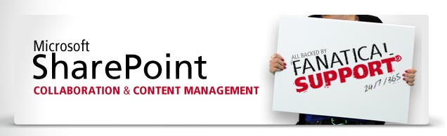
"With SharePoint, Rackspace is offering businesses the most powerful file sharing and collaboration software on the market today," said Pat Matthews, General Manager of Rackspace Email & Apps. "With our cloud delivery model, businesses can take advantage of all the power Microsoft SharePoint has to offer without the hassle of having to manage the software in-house. Microsoft SharePoint backed by Fanatical Support is the recipe our customers have been asking for."
The Rackspace offering includes an intuitive control panel that allows administrators to quickly initiate SharePoint, add/remove users, and create SharePoint sites with only a few steps. The control panel also gives administrators the ability to manage Rackspace Email & Apps' full suite of applications, including hosted Microsoft Exchange, Rackspace Email, Email Archiving, and Rackspace Cloud Drive and Server Backup, in one dashboard.
With SharePoint from Rackspace, employees can become better equipped to collaborate on projects and share ideas across the organisation, with a centralized place to store, organise, and access documents.
Specific features and benefits include:
Collaboration and Social Computing - Allows teams to work together effectively, collaborate on and publish documents, maintain task lists, implement workflows, and share information through the use of wikis and blogs.
Document Management - Organise files and share with team members in one central location.
Team Organisation - Easily customizable for different teams with workflows that fit specific projects. Automatic alerts keep team members up to date.
Microsoft Office Integration - Smoothly integrate with Outlook, Word, Excel, and PowerPoint.
Enterprise Search - Quickly and easily find people, expertise, and content within organisations.
In addition to the new hosted SharePoint offering, Rackspace continues to offer Dedicated SharePoint through its managed services division for customers who require higher levels of customization or control. Dedicated SharePoint is a single tenant solution, supported by a team of certified Rackspace SharePoint engineers who design, deploy, customize and fully manage the solution.
Notes to editors:
About Rackspace Email & Apps
Rackspace Email & Apps, the rapidly growing software-as-a-service division of Rackspace Hosting, offers a full suite of hosted email, collaboration, and storage solutions. The Email & Apps division hosts more than 1.6 million paid email accounts through its proprietary web-based platform, Rackspace Email, Microsoft's Hosted Exchange, and a hybrid offering of the two services all backed by Rackspace's 24x7 Fanatical Support. In 2009, the Email & Apps division processed more than 30 billion emails and blocked more than 17 billion pieces of spam and 500 million viruses.
About Rackspace Hosting
Rackspace Hosting is the world's leader in hosting and cloud computing and has been ranked in the Financial Times Top 50 Great Place to Work in the United Kingdom for the past five years. Rackspace provides its customers with Fanatical Support by delivering a portfolio of hosted IT services, including Managed Hosting, Cloud Hosting, Virtualisation, Dedicated Servers and Email and Apps.
For more information, please contact:
Mital Joshi
Rocket PR
Palladia
20 Garrick Street
London
08453 707 024
WC2 E9BT

~~~~~

Press release distributed via EPR Network (http://express-press-release.net/submit-press-release.php)

