Knowledge To Action Stock Market Seminars Supply International Demand
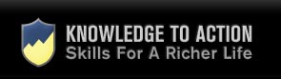

Released on: March 24, 2010, 8:28 am
Author: Estee Chaikin - Knowledge to Action
Industry: Financial
London, UK, March 2010 - Knowledge to Action, Europe's largest trader coaching company, is expanding to offer its forex trading seminars in Singapore, Australia and New Zealand. This follows greatly increased demand for these events, at which attendees gain valuable insights into becoming successful private traders on the foreign exchange markets.
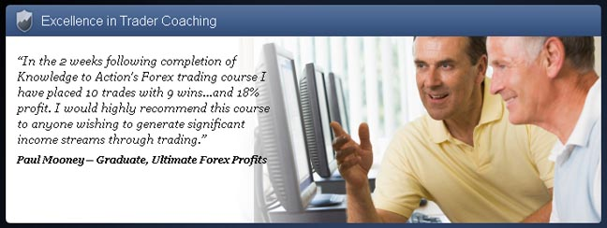
Knowledge to Action originally started running stock market training in 2004 and launched its forex training courses in 2008. Knowledge to Action previously only held seminars in the UK, which houses its Trader Centre of Excellence and one of London's most successful private trading floors.
After speaking to sell out Australian audiences in 2009, Knowledge to Action is officially launching an office in Australia this month. This offers more opportunities for private individuals to benefit from Knowledge to Action's strategies and systems for gaining financial independence through stock market and forex trading. People living in Australasia can now benefit from these training events.
The company was set up by Greg Secker, who spent years working across foreign exchange trading floors in Europe and the US. He set up Knowledge to Action in 2003 in his home and soon expanded, offering stock market courses from 2004. The company has grown and developed explosively in the period since then, so that it is now the number one trader coaching company in Europe, and is on track to expand into the United States in the second half of 2010.
This growth over a period of just a few years is testimony to the effectiveness of Knowledge to Action's award-winning forex training and stock market training courses, which are run from its London Headquarters. The success of this training was recognised recently by the company winning a place as a regional finalist in the 2009 National Business Awards.
About Knowledge to Action
Knowledge to Action, founded by Greg Secker, is the home of the award-winning Traders University® programme, and Europe's number one trader coaching company. Its stock market course has launched many private traders on the path to financial independence since 2004.
For further details, see the company's website at www.knowledgetoaction.co.uk , or on the following social networking sites: Greg Secker on Twitter and Knowledge to Action on Twitter. Greg Secker on LinkedIn and Knowledge To Action on Facebook, or on Greg Secker's blog.
Contact details:
Estee Chaikin
0207 751 8900
marketing@knowledgetoaction.co.uk
http://www.knowledgetoaction.co.uk
~~~~~

Press release distributed via EPR Network (http://express-press-release.net/submit-press-release.php)

