BabyShowerStuff.com Introduces New Baby Shower Themes
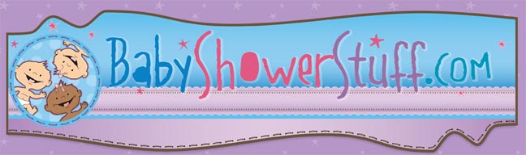

Released on: April 30, 2010, 3:37 am
Author: BabyShowerStuff.com
Industry: Retail
New baby shower themes add creativity to baby shower planning and makes shopping a fun, pleasant experience
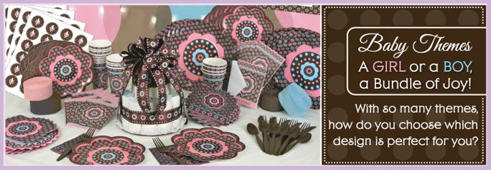
MENOMONIE, Wis., April 2010 -- BabyShowerStuff.com, the ultimate online retailer ofbaby shower favors, baby shower invitations, and baby shower tableware, introduces new theme ideas and matching accessories to create the perfect baby shower. Offering 75 total theme ideas, BabyShowerStuff.com helps customers find everything for their baby showers, from the invitations to the baby shower decorations.
“When a baby is on the way, one of the most memorable occasions is the baby shower,”
said Sherri Yukel, founder, BigDotofHappiness.com. “Our new themes lend creative ideas for baby showers and provide everything customers need to personalize their baby showers. Whether the mother-to-be loves owls, elephants, ladybugs, or is just a“trendy mommy” in the making, BabyShowerStuff.com has the perfect baby shower theme to match her likes.”
Fresh new themes include Owl – Look Whooo’s Having a Baby, Silhouette Couples, Baby Elephant, Baby Turtle, Baby Carriage, Airplane and Construction Truck. Some of the site’s best selling themes are: Monkey Boy, Zoo Crew, Mommy Silhouette and Modern Ladybug. Shoppers can browse through the latest themes and view each theme’s accessories, which includes everything from invitations to name tags to dinner plates to decorations and accessories.
For added convenience and savings, BabyShowerStuff.com also offers party packs for select themes. Party packs come in service for 16 or 32 guests.
BabyShowerStuff.com online store features an expanded categories list that enables customers to easily locate the exact items needed to plan the perfect shower. In keeping with its commitment to customer service, the retailer has launched Twitter and Facebook pages to communicate the latest updates regarding the company’s site, showcase the hottest new items, and allow customers to interact with the company, and with fellow baby shower planners and fans of BabyShowerStuff.com.
About BabyShowerStuff.com
The Baby Shower Event Specialty Site, BabyShowerStuff.com is a company run by fanatics who personalize favors, invitations, games, banners and gifts. The company, which is a division of BigDotOfHappiness.com, features exclusive original baby shower games, baby shower tableware, baby shower decorations and more, and employs“expert experts” to guide and assist customers all the way to the perfect baby shower and help them become party planning heroes.
About BigDotofHappiness.com
BigDotofHappiness.com began as a hobby in the living room of its founder, Sherri Yukel. Today, the site provides all the imaginable party and event items under one roof. BigDotofHappiness.com is the premier event party company specializing in baby showers, bridal showers, wedding showers, bachelorette parties, birthday parties, party invitations and party favors. Thanks to its creative staff, BigDotofHappiness.com is the originator of unique games, invitations and themed party supply products known as "Big Dot Originals."
# # #
Press Contact:
Brenda Knutson, Manager
Big Dot of Happiness
800.274.4282
Smiles@BabyShowerStuff.com
~~~~~

Press release distributed via EPR Network (http://express-press-release.net/submit-press-release.php)

