Lloyds TSB Is Searching For The The Weather Photographer of the Year
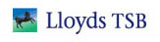

Released on: April 14, 2010, 12:08 am
Author: Chris Blackwood
Industry: Financial
A leading panel of award-winning photographers and acclaimed meteorologists launched a major amateur weather photography competition – with a top prize of £10,000.
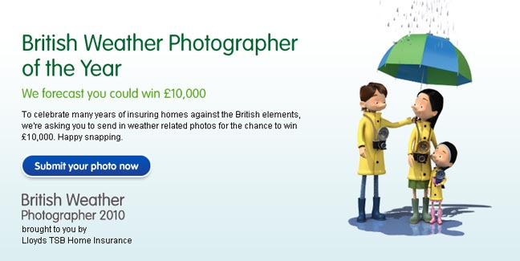
The Lloyds TSB Insurance Weather Photographer of the Year will run for six months, culminating in a public exhibition in London where the finalists’ entries will be on show ahead of the winner being announced in November.
The winner will be chosen by an expert panel featuring acclaimed weather photographers Roger Coulam and Mark Humpage – who will be looking for images that capture our love of the weather, demonstrate originality and creativity, and chart the ever changing British climate.
In addition, the public will also have the opportunity to vote on their favourite pictures online, with £100 going to the most popular photo uploaded each week.
Entrants can upload their photos at http://www.lloydstsb.com/weathercompetition.
The Lloyds TSB Insurance Weather Photographer of the Year has been organised by the leading insurer, which is proud to sponsor the Channel 4 weather.
Paula Llewellyn, Head of Marketing Services at Lloyds TSB Insurance said: "As a proud sponsor of the Channel 4 weather, we’ve launched the Lloyds TSB Insurance Weather Photographer of the Year Competition so Brits can show us what they love about the climate, and what ‘British Weather’ means to them."
Lloyds TSB Home Insurance provides cover for a range of weather related problems such as windstorm and lightning damage.
Important information
1. For full terms and conditions, please visit lloydstsb.com
2. Entry not available for employees of Lloyds Banking Group and their immediate families.
3. The promoter of this competition is Lloyds TSB Insurance Services Limited, registered in England and Wales (No.968406) with registered office at 25 Gresham Street, London EC2V 7HN.
4. Entrants may submit more than one photograph.
5. The competition will run on lloydstsb.com website from 1 April 2010 until 30 September 2010.
6. This is an internet based promotion only.
7. The competition is only open to amateur photographers. By this we mean that entrants should not earn more than 10% of their total annual income or £5,000 annually from photography.
Lloyds TSB Insurance Services Limited, registered in England and Wales (No.968406) with registered office at 25 Gresham Street, London EC2V 7HN
Contact Details: Chris Blackwood, B&B Comms
Tel 020 7419 8635 Mob: 0779 524 7275 or Email: chris.blackwood@bbpr.com
~~~~~

Press release distributed via EPR Network (http://express-press-release.net/submit-press-release.php)

