AmCorp Management Links With New Utility Auditor
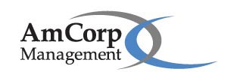
Released on: May 25, 2010, 05:04 am
Author: AmCorp Management, Inc.
Industry: Financial
COLORADO SPRINGS, Colorado – AmCorp, announces that it has entered into a new agreement with one of the nation's most successful utility auditing firms. The agreement established Michael and Paul Kerkorian as their head utility auditing division for AmCorp Analytics, Inc.
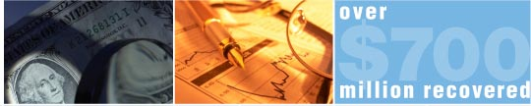
The Kerkorian's have spent almost twenty years building one of the most successful utility auditing firms in America and with the AmCorp agreement they will be able to help companies recover lost revenue across the entire country.
AmCorp helps small and midsize companies recover lost revenue through providing risk free analysis of their expenses. They provide audit and analysis services for workers' compensation, utility audits, telecom audits and cost segregation services. Darren Oliver, the President of AmCorp stated that many times the billing errors are by accident, however sometimes the billing errors and miss-billing practices are from providers attempting to scam the end user. Our job is to identify the money and recover it regardless on why it happened.
Contact Details: Darryl Oliver, COO
Corporate Communications
888-585-2318
oliver@amcorpmanagement.com
~~~~~

Press release distributed via EPR Network (http://express-press-release.net/submit-press-release.php)

